

TRIBHUVAN UNIVERSITY

INSTITUTE OF SCIENCE AND TECHNOLOGY



HIMALAYA COLLEGE OF ENGINEERING

CHYASAL, LALITPUR

LAB REPORT NO. 13

**SUBMITTED BY: SUBMITTED TO:**

NAME: ABIN TIMILSINA DEPARTMENT OF Bsc. CSIT

ROLL NO.: 04 CHECKED BY:

**THEORY**

*File:*

File is a sequence of character or bytes stored on secondary device.

Steps involved to create pointer variable are:

1. Create file pointer variable: FILE*<File_pointer_name>
2. Initialization file pointer: fp=(“file name”, “”file mode”);
3. Perform read/ write operation on file.
4. Close the file: fclose();

*File Mode*

1. r=read mode only
2. w=write mode only
3. a=append mode only
4. rt=read and write mode
5. wt=read and write mode
6. at= read and write mode

*Standard Library Function*

* Character Input and Output

1. fgets():Syntax: ch=fgets(<file.pointer>)
2. fputs(): Syntax: fputs(ch,<file_pointer>)

* String input /output

1. fgets(): Syntax: fgets(string_var,int size,file_pointer);
2. fputs(): Syntax: fputs(string_var,<file.pointer>);

*File handaling in Binary*

1. file pointer
2. fopen
3. read/write operation
4. fread(): Syntax:fread(&<variable>,sizeof(variable),count,<file_pointer>);
5. fwrite():Syntax:fwrite(&<variable>,sizeof(variable),count,<file_pointer);

**Question 1**

**Write a c program to write string into file abc.txt and read that string from file (using fputs and fgets function)**

#include<stdio.h>

int main()

{

FILE *fp;

char c[100];

fp=fopen("abc.txt","w");

printf("enter a string \n");

gets(c);

fputs(c,fp);

fclose(fp);

fp=fopen("abc.txt","r");

printf("the entered value is \n");

fgets(c,10,fp);

printf("%s",c);

fclose(fp);

return 0;

}

*Program:*

#include<stdio.h>

int main()

{

FILE *fp;

char c[100];

fp=fopen("abc.txt","w");

printf("enter a string \n");

gets(c);

fputs(c,fp);

fclose(fp);

fp=fopen("abc.txt","r");

printf("the entered value is \n");

fgets(c,10,fp);

printf("%s",c);

fclose(fp);

return 0;

}

*Output:*

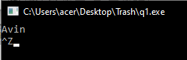

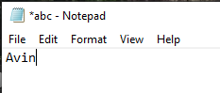

**Question 2**

**Write a c program to create and write n numbers in file “number.txt” open this file than read its content and put all even number on one file “even.txt” and odd number on another file “odd.txt”.**

*Program:*

#include<stdio.h>

int main()

{

FILE *fn,*fo,*fe;

int n,i,num;

printf("enter the value of n \n");

scanf("%d",&n);

fn=fopen("number.txt","w");

for(i=1;i<=n;i++)

{

fprintf(fn,"%d\t",i);

}

fclose(fn);

fn=fopen("number.txt","r");

fo=fopen("odd.txt","w");

fe=fopen("even.txt","w");

while(fscanf(fn,"%d",&num)!=EOF)

{

if(num%2==0)

{

fprintf(fe,"%d\t",num);

}

else

{

fprintf(fo,"%d\t",num);

}

}

fclose(fn);

fclose(fo);

fclose(fe);

return 0;

}

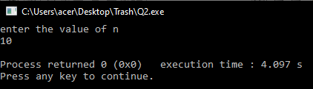*Output:*

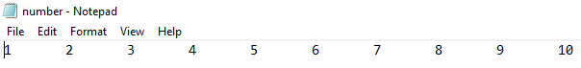

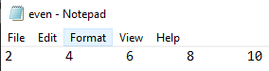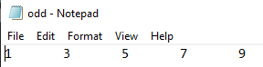

**Question 3**

**Write a c program to create and write name, address and age of person and read it.**

*Program:*

#include<stdio.h>

struct person

{

char name[20];

char add[20];

int age;

}p;

int main()

{

FILE *fp;

fp=fopen("person.txt","w");

printf("enter the info about the person \n");

scanf("%s%s%d",&p.name,&p.add,&p.age);

fprintf(fp,"%s %s %d",p.name,p.add,p.age);

fclose(fp);

fp=fopen("person.txt","r");

printf("the entered info is \n");

fscanf(fp,"%s %s %d",p.name,p.add,&p.age);

printf("%s %s %d",p.name,p.add,p.age);

fclose(fp);

return 0;

}

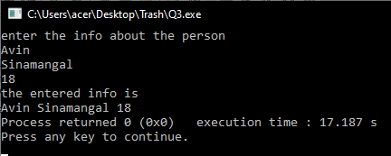*Output:*

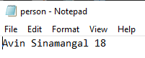

**Question 4**

**Write a c program to edit the file f1.txt having text “I love java program” with string “C program” instead of java program.**

*Program:*

#include<stdio.h>

int main()

{

FILE *fp;

char w[30];

fp=fopen("f1.txt","wt");

fprintf(fp,"I love java program");

int n=ftell(fp);

printf("current position of pointer= %d",n);

fseek(fp,7,0);

fputs("c programming",fp);

rewind(fp);

fclose(fp);

return 0;

}

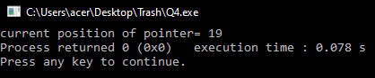

*Output:*

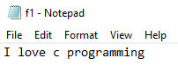

**Question 5**

**WAP to draw circle, line, rectangle, arc, ellipse, triangle.**

*Program:*

#include<stdio.h>

#include<conio.h>

#include<Graphics.h>

void main()

{

int gd=DETECT, gm;

initgraph(&gd,&gm C:\\TurboC3\BGI");

circle(50,50,50);

line(200,200,300,300);

rectangle (50, 100, 150, 200) ;

arc (100, 100, 50, 30, 70) ;

ellipse(50,50,30,90,50,75);

line (150, 100, 70, 60) ;

line(150,100, 150,200) ;

line(70,60,150,200);

 getch() ;

closegraph();

}

*Output:*

**Question 6**

**WAP to draw circle having radius of 100 pixel with filling solid redcolor.**

*Program:*

#include<stdio.h>

include<conio.h>

include<Graphics.h>

void main()

{

int gd=DETECT, gm;

initgraph(&gd,&gm C:\\TurboC3\BGI");

setfillstyle(SOLID_FILL,RED);

circle(50,50,100);

floodfill(45,45,45,WHITE);

getch() ;

closegraph();

}



*Output:*

**Conclusion**

From this we can conclude or we learnt about **File Handling** and how it is used in array, string which makes us easy for programming and we also learned about **Graphics** and learned to solid fill color.